**UIT University**

**BACHELOR OF SCIENCE (SOFTWARE ENGINEERING)**

**CIC-201 Artificial Intelligence**

**PROJECT REPORT**

**TITLE:**

**Wildlife Classifier**

**GROUP MEMBERS:**

**Muhammad Hassam Bin Zahid 22SP-019-SE**

**Abhia Sultana 22SP-026-SE**

**Ruba Syed 22SP-053-SE**

**Huraira Riaz 22SP-036-SE**

# **Motivation & Scope:**

Accurate and efficient monitoring is crucial for effective wildlife conservation. Traditional methods, such as manual tracking and camera traps, are often labour-intensive and limited in their coverage. Utilizing AI and machine learning allows us to automate wildlife classification, significantly boosting efficiency and accuracy. This project seeks to advance conservation efforts and ecological research by offering a scalable solution for wildlife monitoring.

The scope of this Project includes collecting and annotating wildlife images, developing and refining machine learning models for species classification, and deploying a user-friendly application for real-time monitoring. It also involves field testing and providing comprehensive documentation and progress reports to ensure the tool's effectiveness and continuous improvement.

# **Problem Statement:**

Effective wildlife conservation is hindered by the limitations of traditional monitoring methods, which are often labour-intensive, time-consuming, and limited in scope. These conventional techniques cannot efficiently handle the large-scale data required for comprehensive wildlife monitoring and management. This inefficiency inhibits our ability to accurately track wildlife populations. There is a pressing need for an automated, scalable solution that can accurately and efficiently classify and monitor wildlife to support conservation efforts and ecological research.

# Solution/Coding:

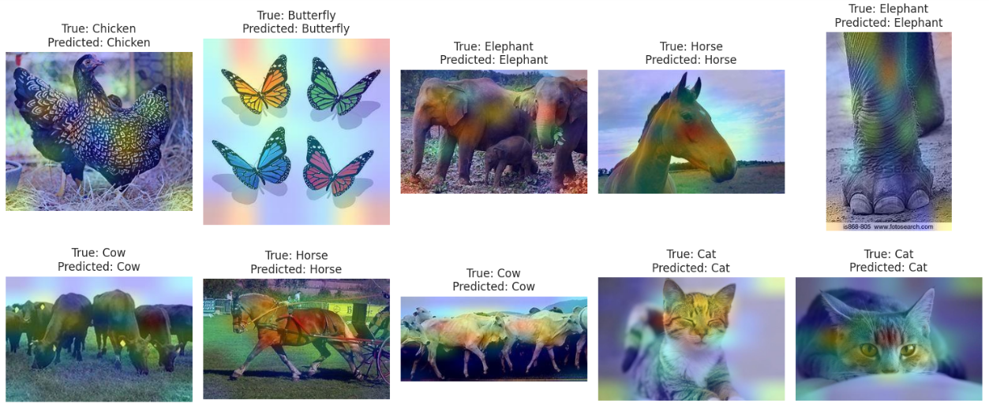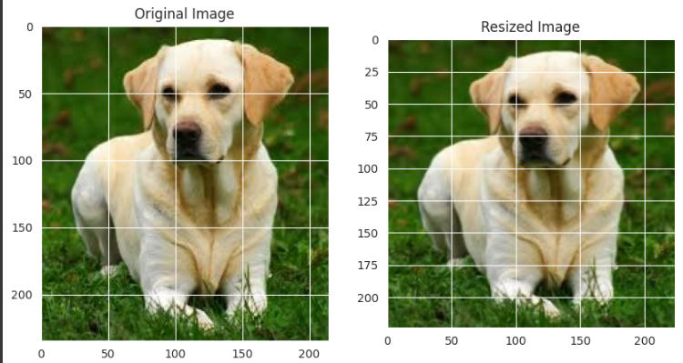

**Evaluation**

The assessment of the wildlife classifier's performance encompasses several key components. Accuracy, representing the percentage of correctly classified instances, provides a fundamental measure of overall effectiveness. Precision, recall (or sensitivity), and F1-score offer deeper insights into classification quality, considering true positives, false positives, and actual positives.

**Results and Comparisons**

The results highlight the classifier's performance across various datasets, emphasizing accuracy, precision, recall, F1-score, and AUC metrics. Comparative benchmarking against other wildlife classifiers or baseline models provides context for assessing its efficacy. Visualizations such as bar charts, line graphs offer intuitive comparisons of performance metrics. Additionally, for a given wildlife image, the classifier makes a prediction based on the dataset.

**Conclusion**

In summarizing the evaluation results, several key findings emerge. The wildlife classifier exhibits notable effectiveness, as evidenced by high accuracy, precision, recall, F1-score across various datasets. These results underscore its reliability in accurately identifying wildlife species. The implications of such performance are significant, particularly in enhancing wildlife monitoring and conservation efforts. By providing a robust tool for species identification, the classifier contributes to more informed decision-making and targeted conservation strategies. Moreover, its ability to generalize to new, unseen data indicates its practicality and potential for broader application in diverse ecological contexts, thereby reinforcing its value in advancing wildlife research and related fields.

**Limitations**

However, despite its strengths, the wildlife classifier is not without limitations. One notable constraint is its processing time, particularly when operating on a system with a slow GPU. Image processing can be time-consuming, especially for large datasets or high-resolution images, which may result in delays in obtaining classification results. Additionally, the classifier's performance relies heavily on a stable network connection, as it often accesses remote databases or cloud-based resources for reference data or model updates. In situations where network connectivity is intermittent or unreliable, the classifier's effectiveness may be compromised, leading to potential delays or inaccuracies in species identification. These limitations highlight the importance of considering hardware capabilities and network infrastructure when deploying the classifier in operational settings, to ensure optimal performance and reliability.

**Future Work**

In future endeavors, optimizing the classifier's algorithms to expedite image processing while maintaining accuracy will be paramount. Additionally, integrating advanced machine learning methodologies, such as transfer learning or ensemble techniques, could augment its ability to generalize and enhance classification precision. Expanding the species database through collaborative efforts and crowdsourcing initiatives will broaden its applicability. Moreover, implementing strategies to bolster resilience against network interruptions, such as offline capabilities or caching mechanisms, will ensure uninterrupted operation in diverse environmental conditions.